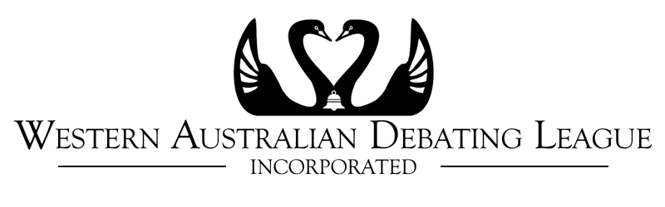
COVID-19 Rules and Regulations
(Amended 17th of March 2021)
The Western Australian Debating League is committed to ensuring the safety and happiness of all participants during our events. In compliance with relevant government regulations and directives from the Department of Health the following regulations are now in effect for all league events. These regulations shall be viewed in conjunction with host schools’ regulations and may be amended by the Executive.
Venue Management
• That in relation to league events a two square metre per person rule shall be enforced for all WADL facilitated events:
o That Debating rooms will have an occupancy limit pursuant to the government’s 2sqm rule.
o Teams are allowed a maximum of 11 attendees, including parents, team members and coordinators.
o That during preparation time students will be given a nominated space to use. This will not change throughout the day.
o Upon completion of a WADL event rooms used by the league will be noted.
• That the league will provide signage including:
o Dedicated Entry
o Dedicated Exit
o Hygiene Instructions
o Social Distancing Reminder
• That hand sanitiser will be available at venues for participant usage.
• That any food provided by the league will be spread around the venue to ensure compliance with social distancing and will be prepared using appropriate personal protective equipment.
• A copy of these regulations will be provided to the lead WADL volunteer.
Personnel Management
• The league will ensure volunteers are allocated to venues on a full day/evening basis only.
• That WADL volunteers will be required to undergo training on how to respond to a COVID-19 incident in addition to managing a venue.
• That all participants will be required to sign in before gaining entry to the venue. These records will be kept in compliance with the league’s “Privacy and Records Policy”.
o Sign in will occur through the SafeWA app or physical registers.
• That all participants will be briefed on good hygiene practices before the event commences.
• That between activities time will be provided for participants to wash their hands.
• That any “communal” time will be staggered to minimise cross-contamination.
• That participants that are sick will be barred from WADL events.
• The league may institute a cap to ensure social distancing is maintained.

